

**User Manual**

MediCare Hospital Management System





## **Manual Overview**

**1.** **About the System** 2

**2.** **System Users** 3

**2.1** **Main Menu Bar** 3

**2.2** **Login Portal** 7

**2.3** **Role of the Doctor** 8

**2.4** **Role of the Nurse** 13

**2.5** **Role of Lab Technician** 16

**2.6** **Role of Administrator** 21

**3.** **FAQ** 35

**4.** **Contact & Support** 36

#### **About the System**

**Welcome to MediCare Hospital Management System**

The system offers high-quality healthcare services, including outpatient consultations, inpatient care, emergency services, and diagnostic procedures, with a focus on care and responsibility. Our Hospital Management System helps doctors, nurses, and staff members to manage patient details and hospital work easily and efficiently.



#### **System Users**

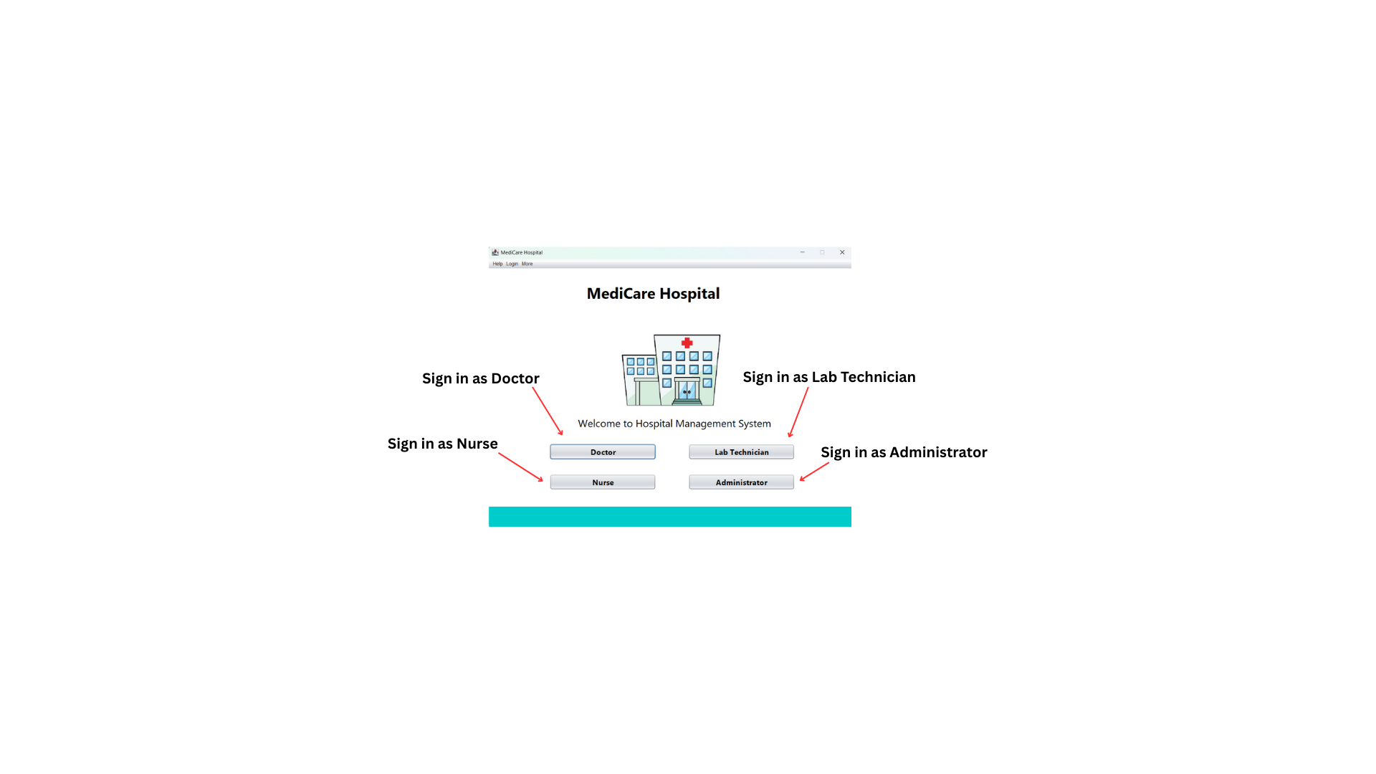When the software is launched, the following interface will appear. This is the Main Login Screen for all users. User can select their role by clicking the buttons. Each button will direct you to the login portal for the specific role.

##### **Main Menu Bar**

At the top of the Main Login Screen, there is a menu bar.

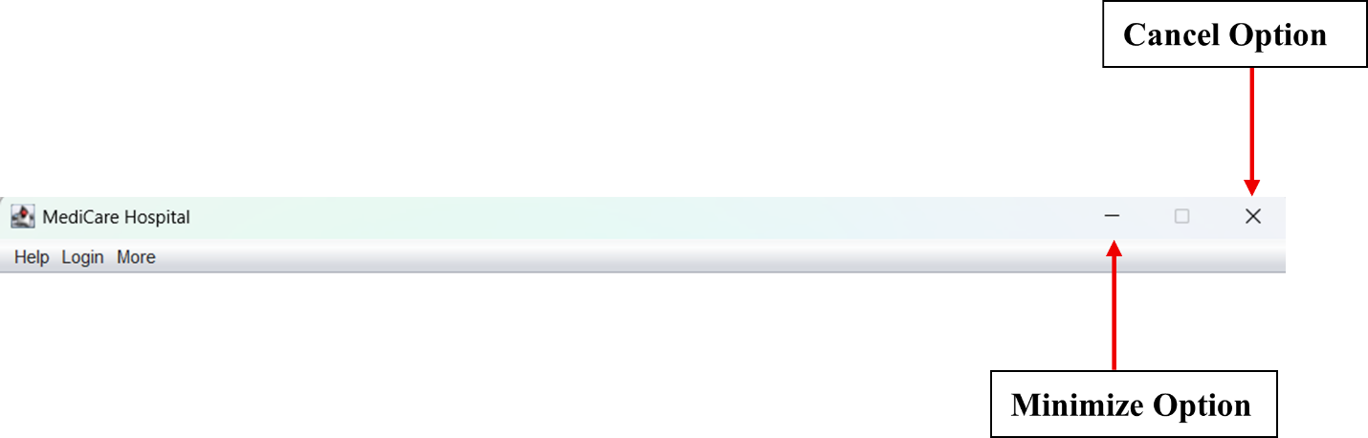

**Help Menu**

Provides quick access to the system.

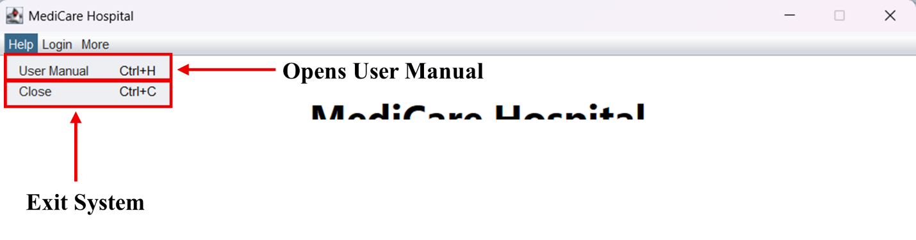

* **User Manual (*Ctrl + H*)**

Opens the User Manual to get guidance for handling the system.

* **Close (*Ctrl + C*)**

Exit from the system immediately.

**Login Menu**

Provides quick login access to the system.

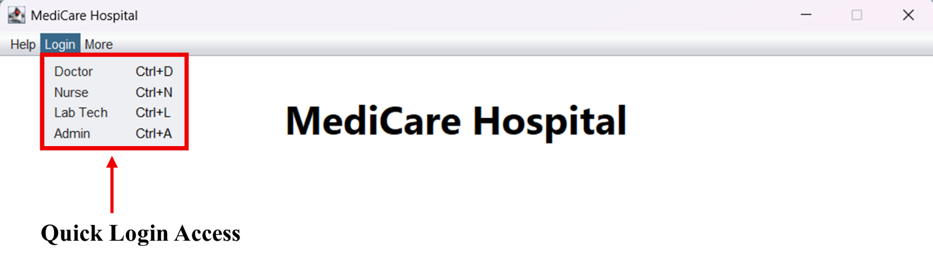

* **Doctor (*Ctrl + D*)**

Sign in as a Doctor to the Login Portal.

* **Nurse (*Ctrl + N*)**

Sign in asaNurse to the Login Portal.

* **Lab Tech (*Ctrl + L*)**

Sign in as a Lab Technician to the Login Portal.

* **Admin (*Ctrl + A*)**

Sign in as an Administrator to the Login Portal.

**More Option Menu**

Provides quick login access to the system.

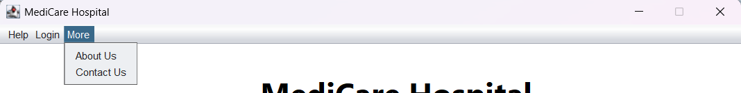

* **About Us**

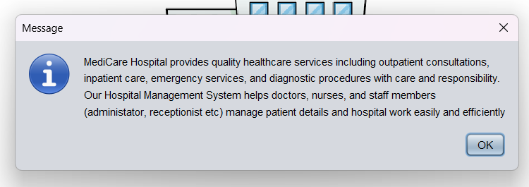To get information about the MediCare Hospital.

* **Contact Us**

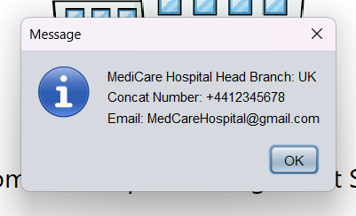Provide Medicare Hospital contact details.

##### **Login Portal**

After selecting the role, you will be displayed to the corresponding Login Portal. Each portal requires to enter the User Name and Password to access the relevant role portal.

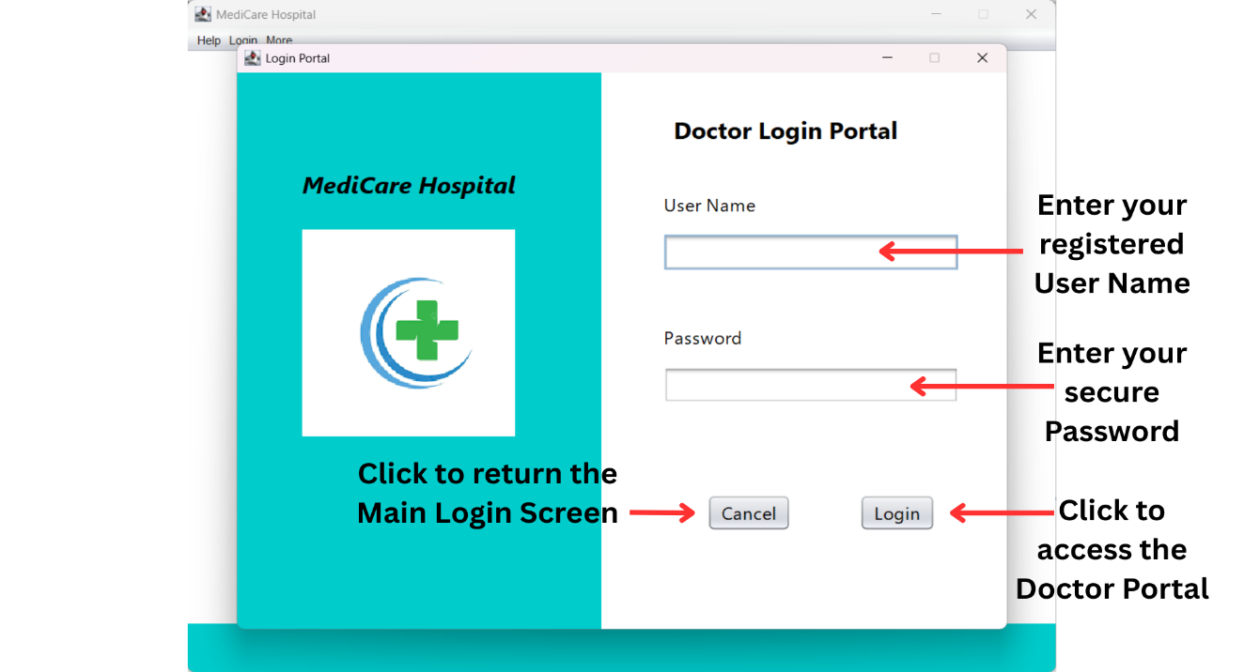

The same login method is used in the Doctor, Nurse, Lab Technician and Administrator login portals. [*Click here to view the demonstration video.*](https://drive.google.com/file/d/1bqlwtps_n-biWj-W8UBf3rrTYvbc_8fa/view?usp=sharing)

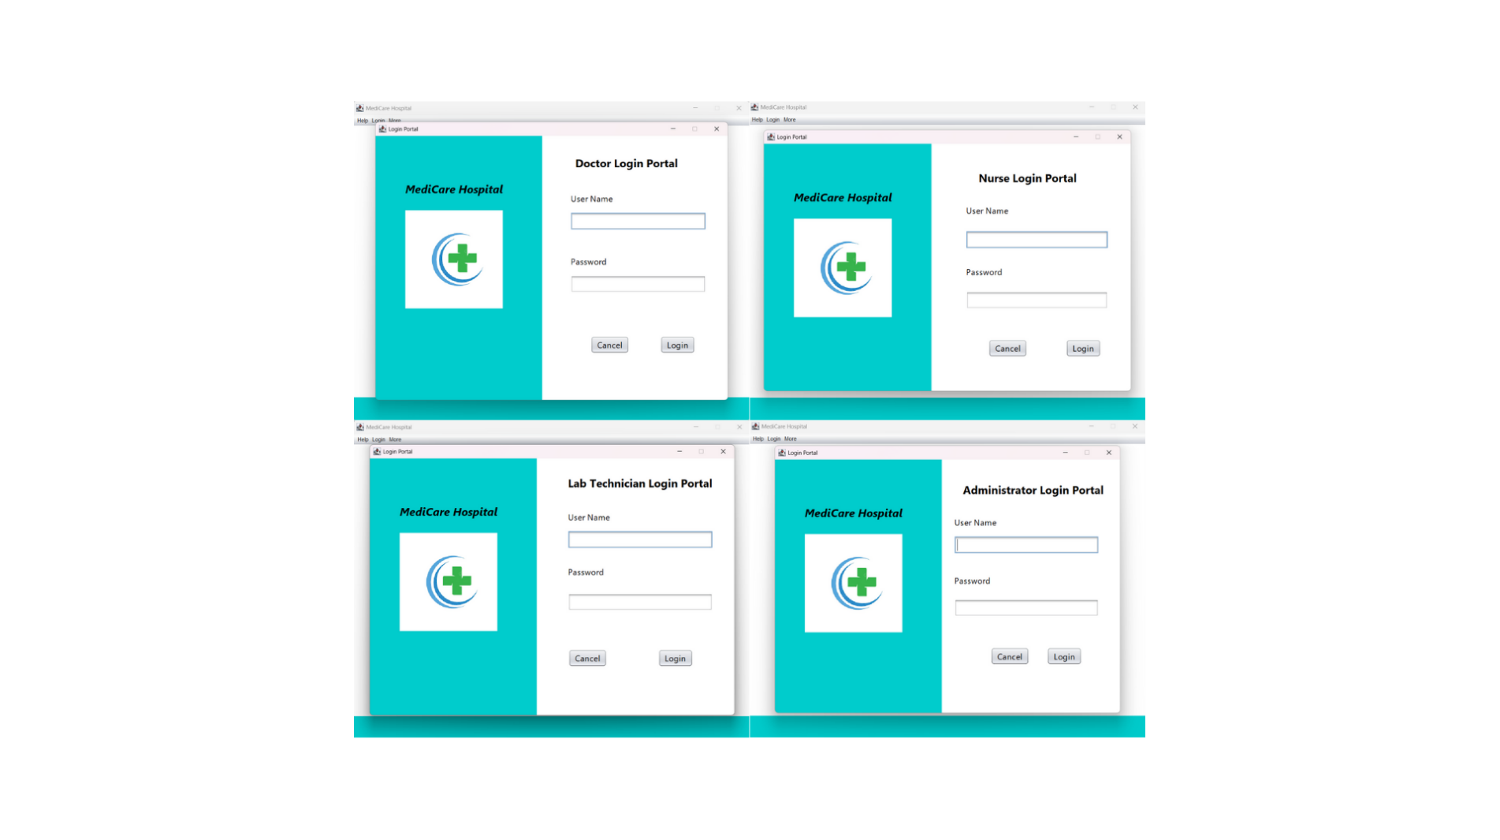

##### **Role of the Doctor**

When a doctor successfully logs in to the system, it will display the Doctor Portal.

**Doctor Portal**

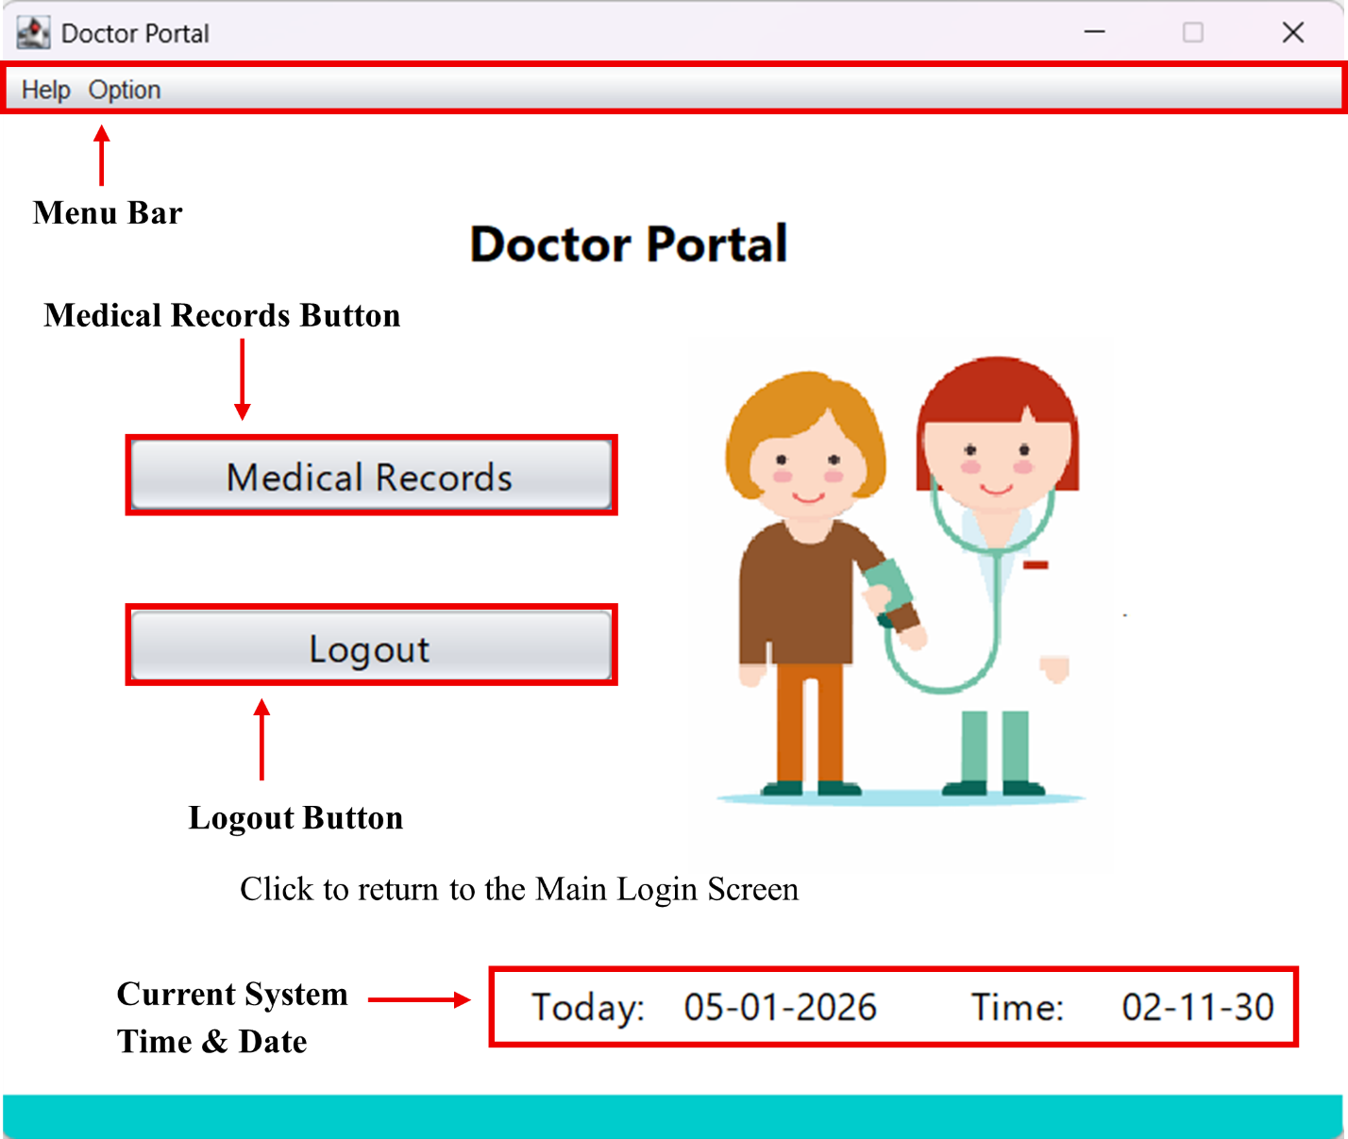

**Menu Bar**

At the top of the Doctor Portal, there is a menu bar.

* **Help Menu**

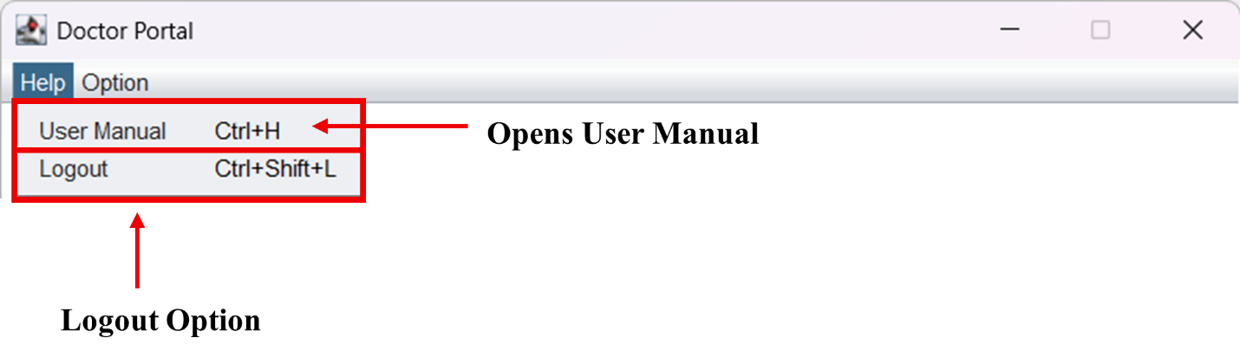

* **User Manual (*Ctrl + H*)**

Opens the User Manual to get guidance for handling the system.

* **Logout (*Ctrl + Shift + L*)**

Return to the Main Login Screen immediately.

* **Option Menu**

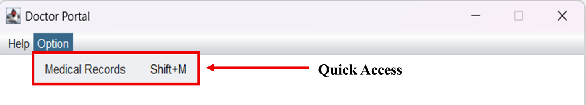

* **Medical Records (*Shift + M*)**

Opens the Medical Records user interface to add data.

###### **Medical Records**

The Medical Record interface provides functions such as adding, displaying, finding, updating, and deleting patient records.

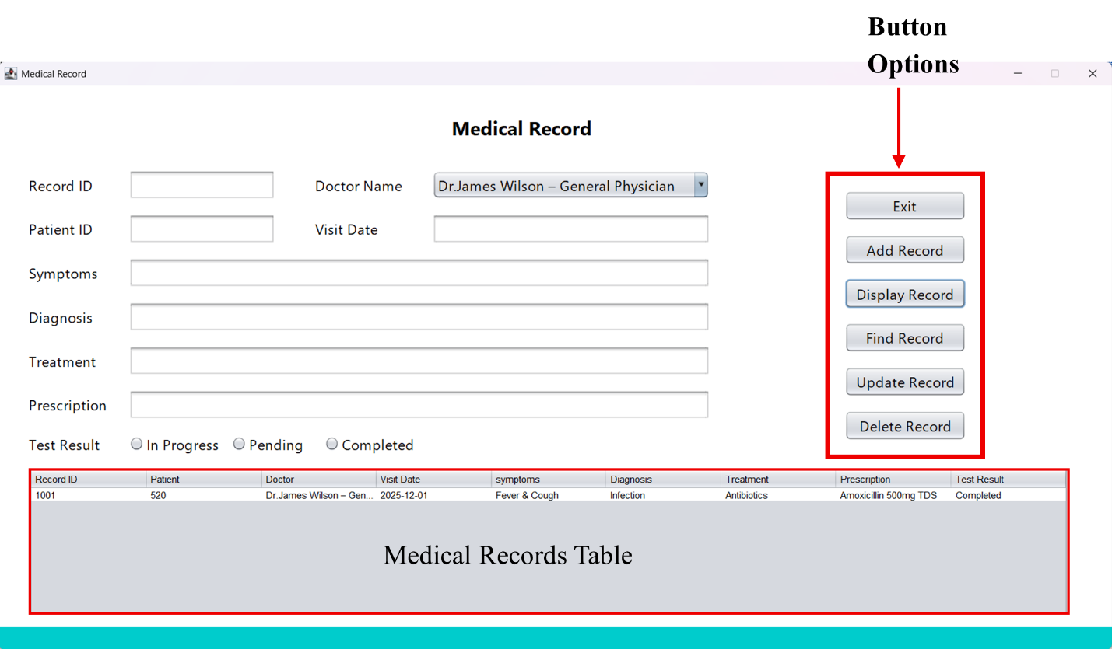

Follow the steps below:

1. Fill in the medical details.
2. Add a new Record

* 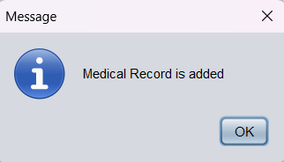Click the **Add Record** button to save.

1. Display existing records

* 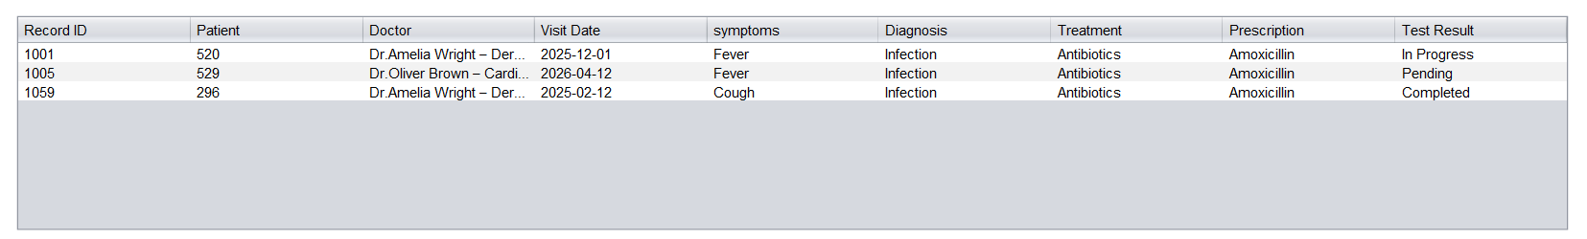Click the **Display Record** button to view records in the table.

1. Find Medical Record

* Click the **Find Record button**.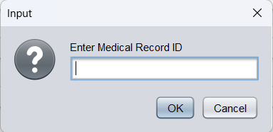
* 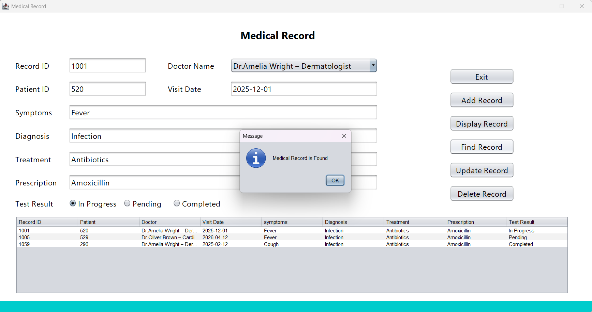Enter the Medical Record ID and click OK.

1. Update Medical Record

* Find the record.
* Update any field.
* 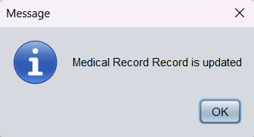Click the **Update Record** button to save changes.

1. Delete Medical Record.

* Click the **Delete Record** button.
* 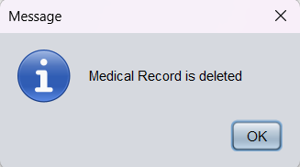Enter the Medical Record ID and click OK.

[*Click here to view the demonstration video.*](https://drive.google.com/file/d/1C8vePbjpS87n5dN31c-XmiEFoXE0UhCe/view?usp=drive_link)

##### **Role of the Nurse**

When a nurse successfully logs in to the system, it will display the Nurse Portal.

**Nurse Portal**

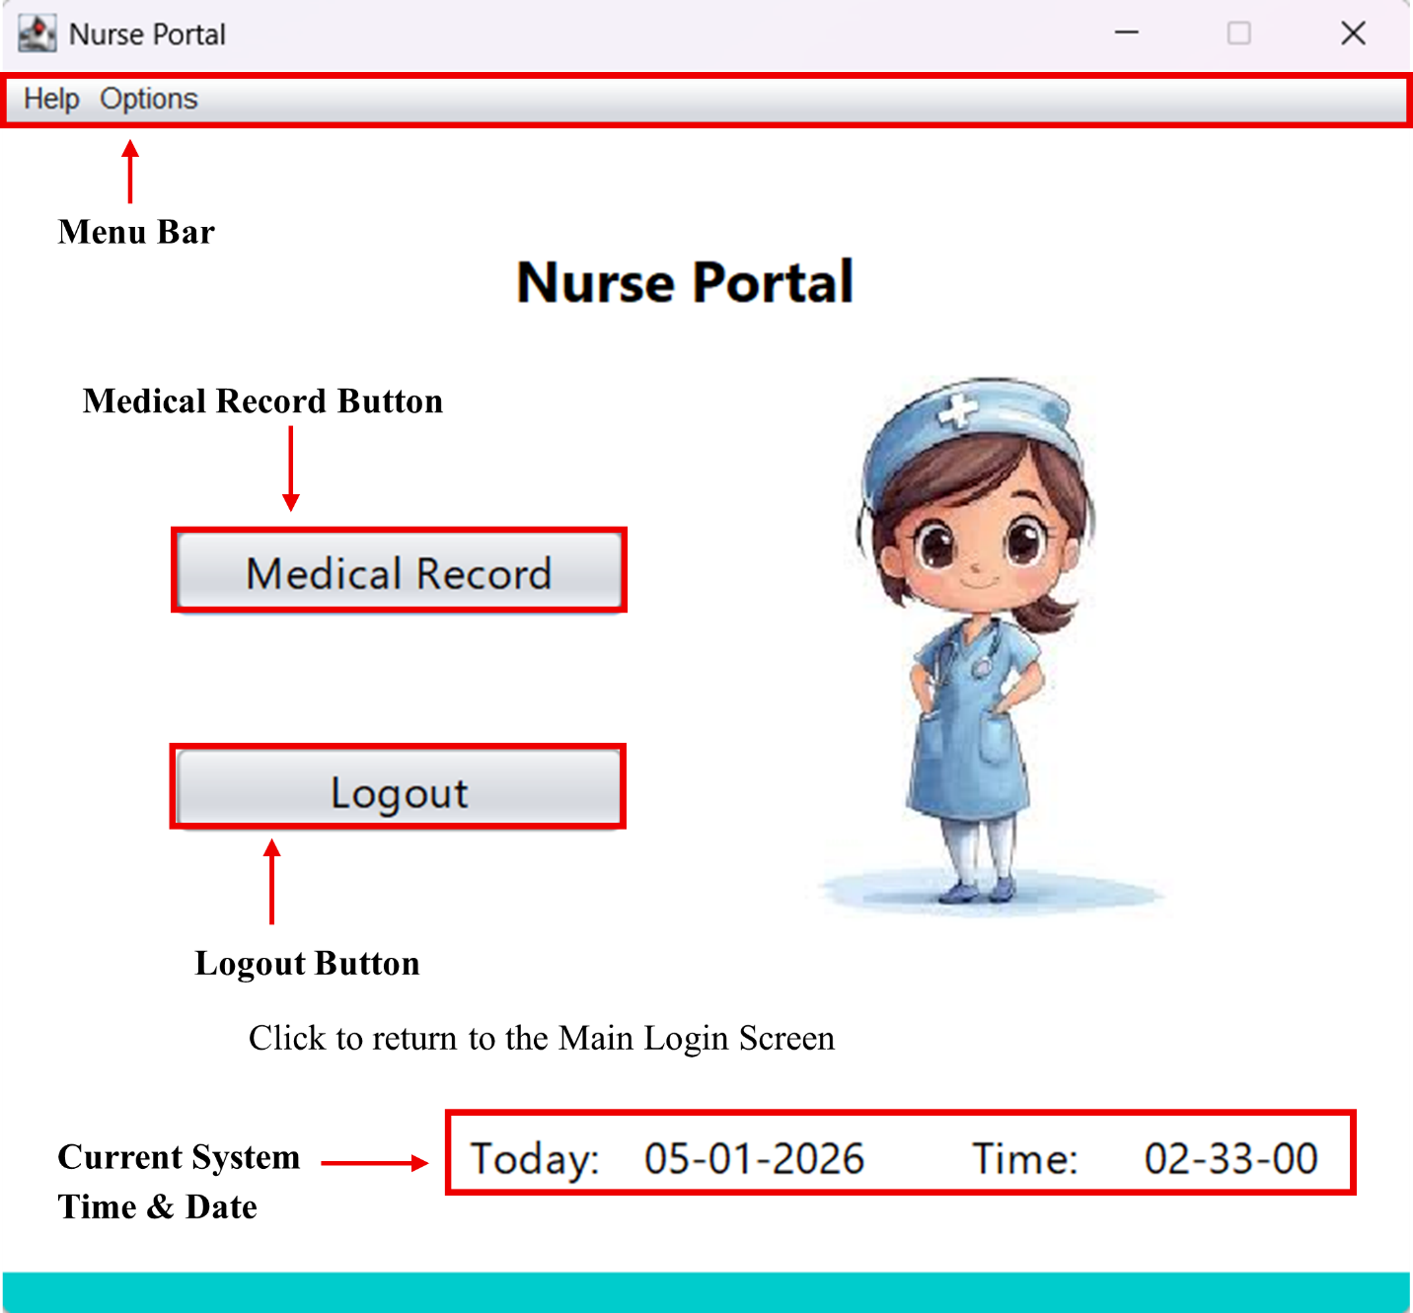

**Menu Bar**

At the top of the Nurse Portal, there is a menu bar.

* **Help Menu**

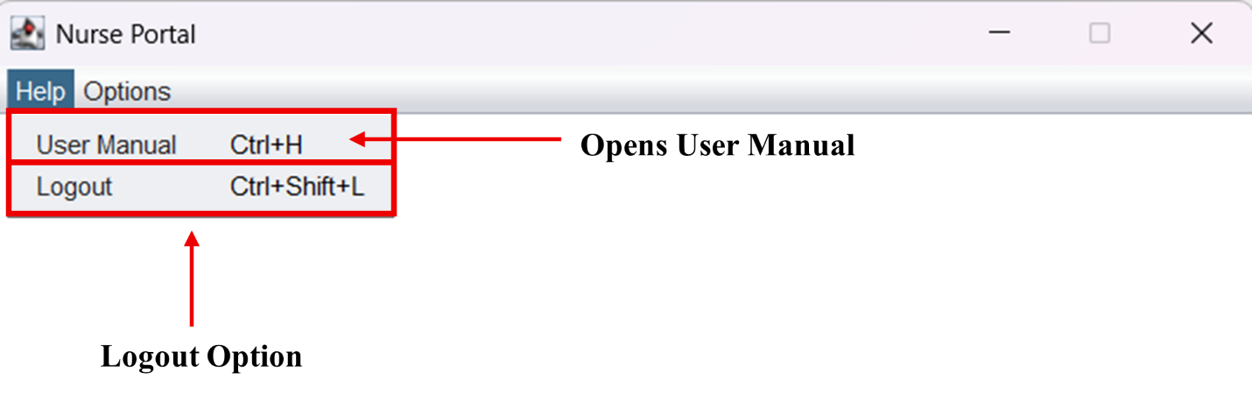

* **User Manual (*Ctrl + H*)**

Opens the User Manual to get guidance for handling the system.

* **Logout (*Ctrl + Shift + L*)**

Return to the Main Login Screen immediately.

* **Options Menu**

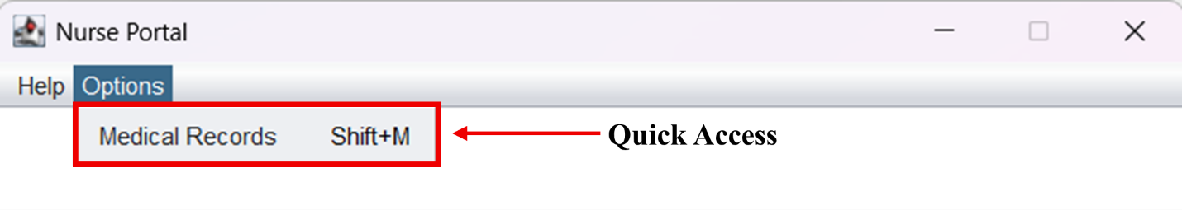

* **Medical Records (*Shift + M*)**

Opens the Medical Records user interface to add data.

**Medical Records**

The Medical Record provides functions such as adding, displaying, finding, updating, and deleting patient records.

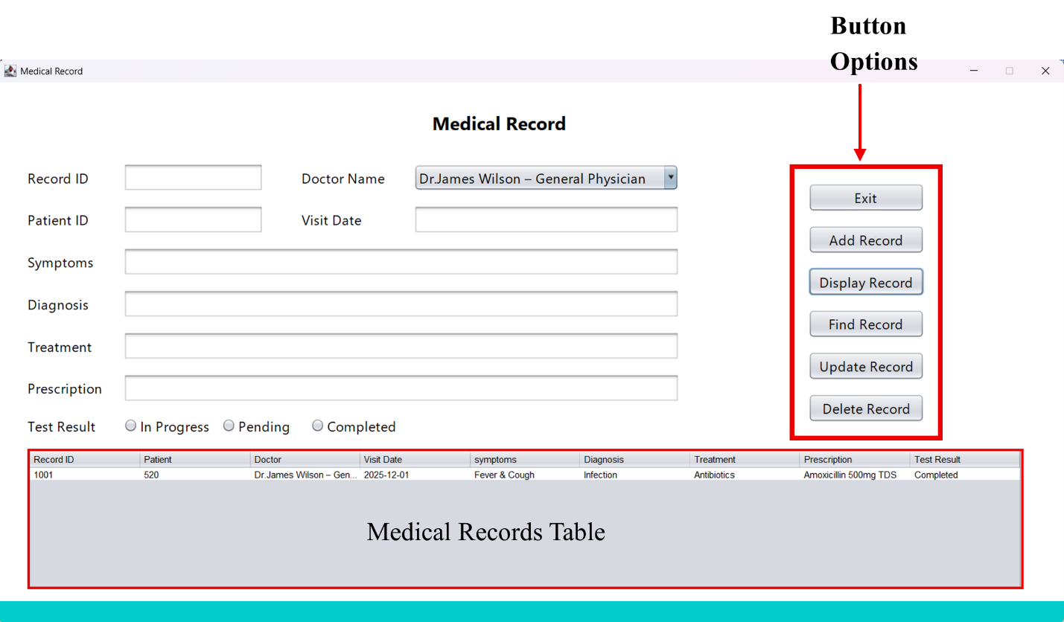

In the Nurse Portal, the Medical Record interface is the same as the Doctor Portal’s Medical Record interface. Please refer to that section for more instructions.

##### **Role of Lab Technician**

When a doctor successfully logs in to the system, it will display the Doctor Portal.

**Lab Technician Portal**

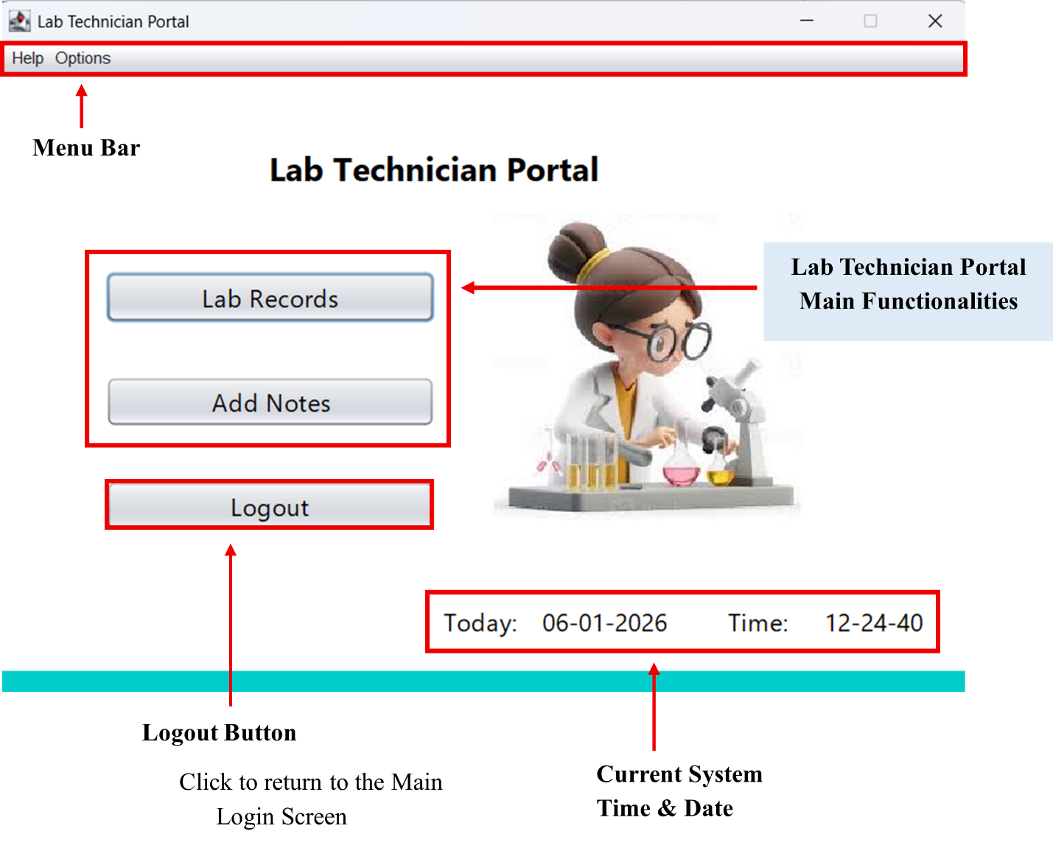

**Menu Bar**

* **Help Menu**

Same as the other Roles’ Portals

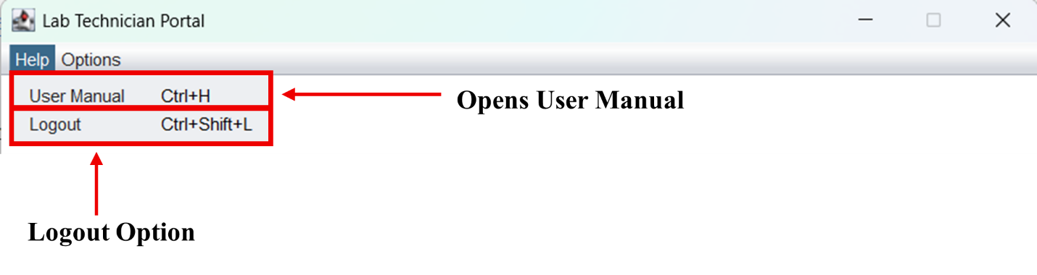

* **Options Menu**

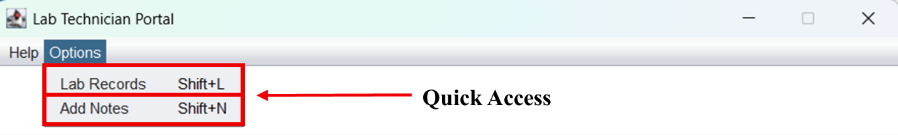

* **Lab Records (*Shift + L*)**

Opens the Lab Records user interface to add data.

* **Add Notes (*Shift + N*)**

Opens the Add Notes user interface to add notes.

**Lab Records**

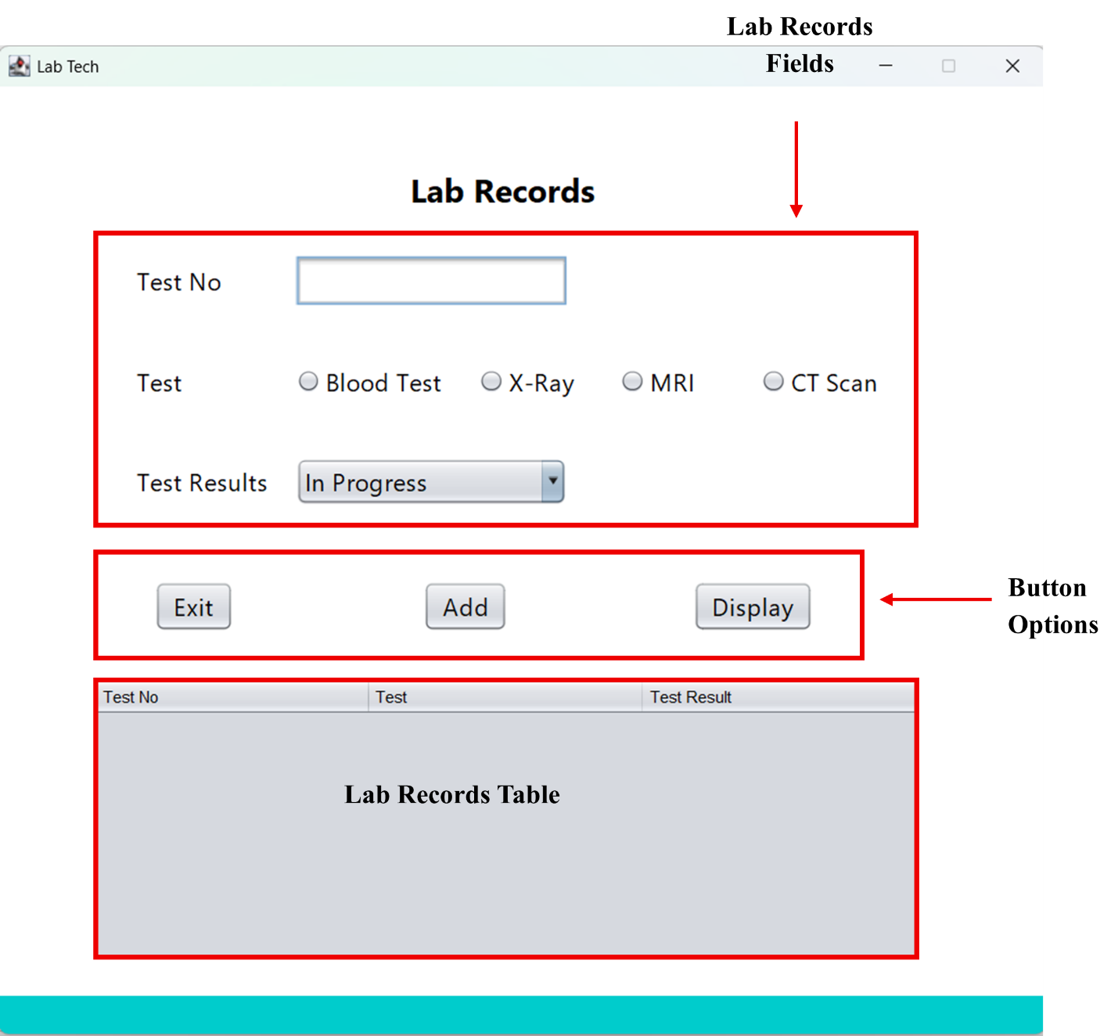The Lab Record provides functions such as adding and displaying lab records.

Follow the steps below:

1. Fill in the lab records.
2. Add a new Record

* 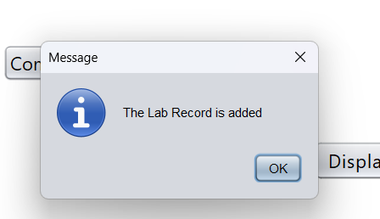Click the **Add** button to save.

1. Display existing records

* 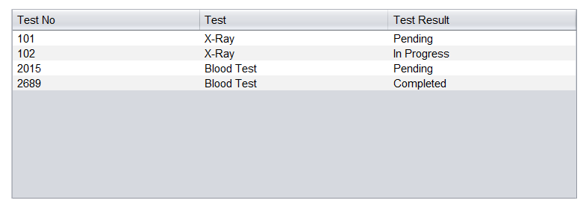Click the **Display** button to view records in the table.

[*Click here to view the demonstration video.*](https://drive.google.com/file/d/1NCP2P8HbbJoGgdZijuRCm51yH9g-kcvu/view?usp=drive_link)

**Add Notes**

The Add Notes option provides adding and saving them to a file.

****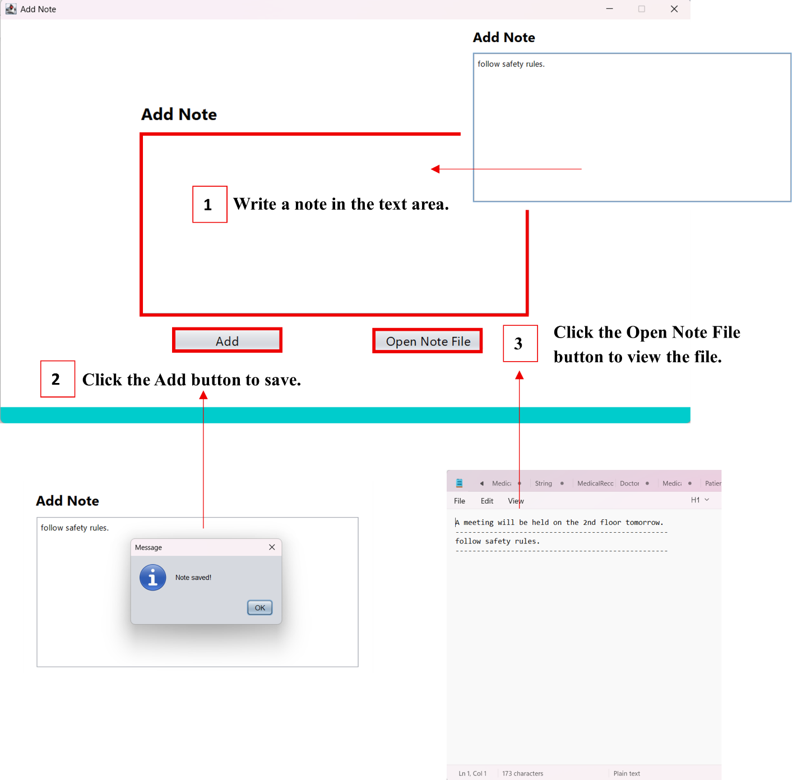

[*Click here to view the demonstration video.*](https://drive.google.com/file/d/1Of44hDYZjsdclxB32CdZbipeJq0bdLjK/view?usp=sharing)

##### **Role of Administrator**

When an administrator successfully logs in to the system, it will display the Admin Portal.

**Administrator Portal**

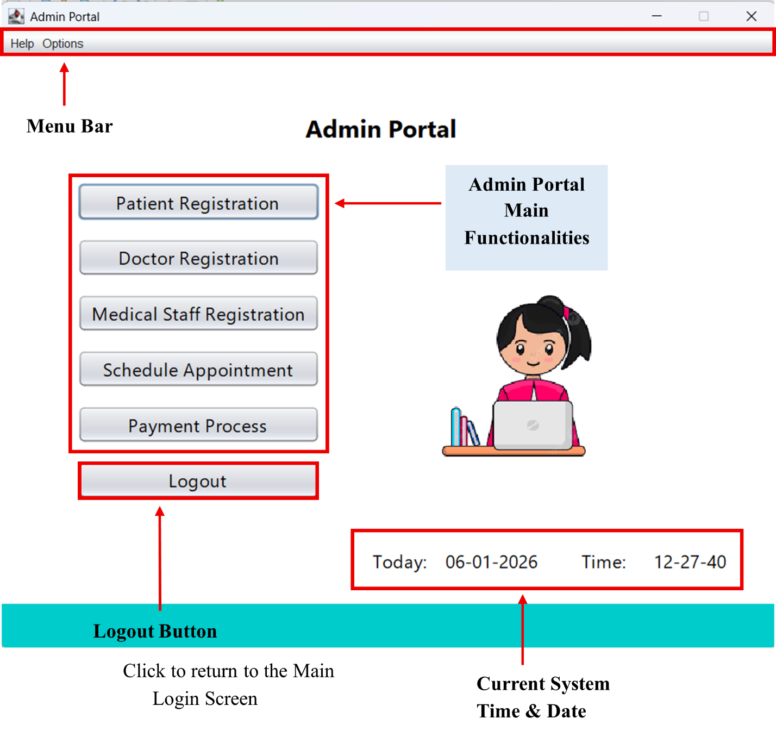

**Menu Bar**

* **Help Menu**

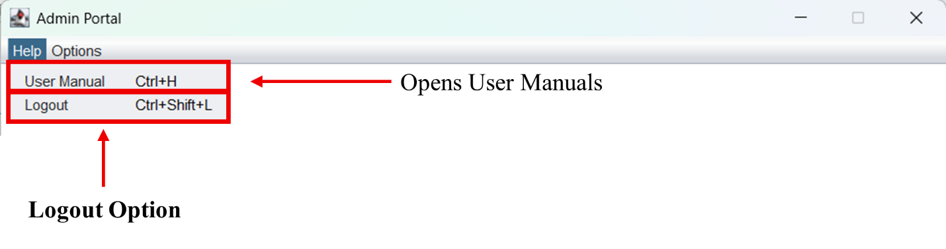Same as the other Roles’ Portals.

* 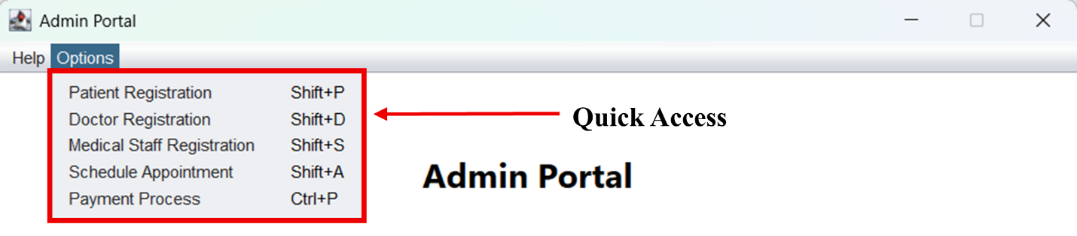**Options Menu**
* **Patient Registration (*Shift + P*)**

Opens the Patient Registrationuser interface to handle the patient details.

* **Doctor Registration (*Shift + D*)**

Opens the Doctor Registration user interface to maintain the doctor's details.

* **Medical Staff Registration (*Shift + S*)**

Opens the Medical Staff Registration user interface to handle the staff details.

* **Schedule Appointment (*Shift + A*)**

Opens the Schedule Appointment user interface to process appointments.

* **Payment Process (*Ctrl + P*)**

Opens the Payment Process user interface to print a receipt.

###### **Patient Registration**

The Patient Registration includes functions such as adding, displaying, finding, updating, and deleting patient profiles.

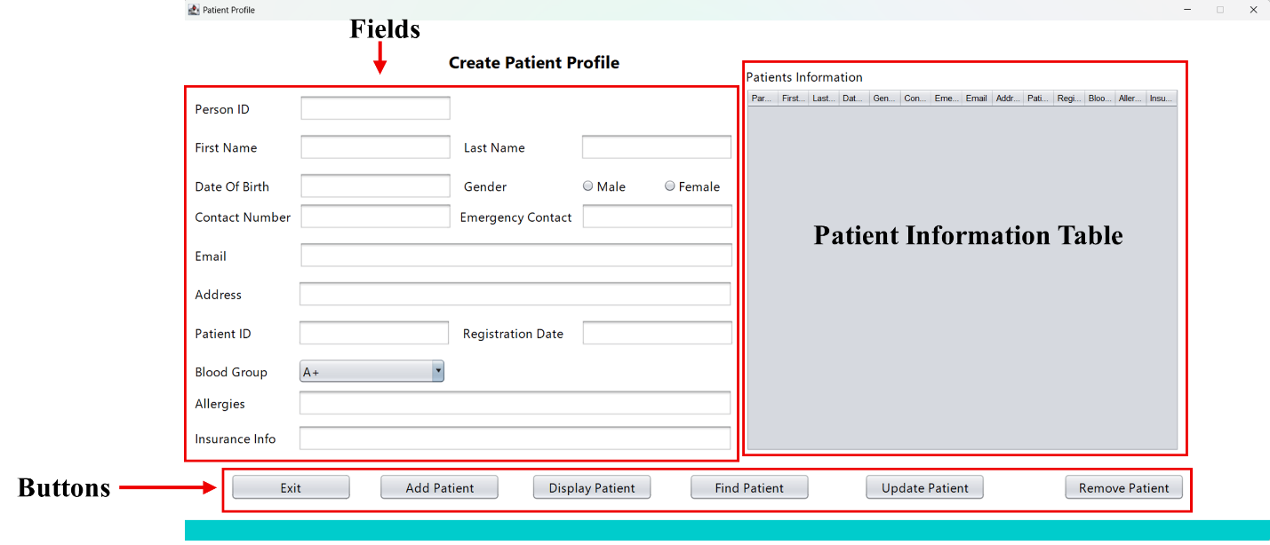

Follow the steps below:

1. Fill in the patient fields.

2. Add a new patient

* 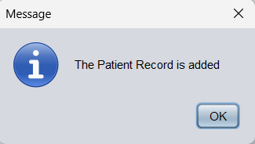Click the **Add Patient** button to save.

1. Display existing records

* 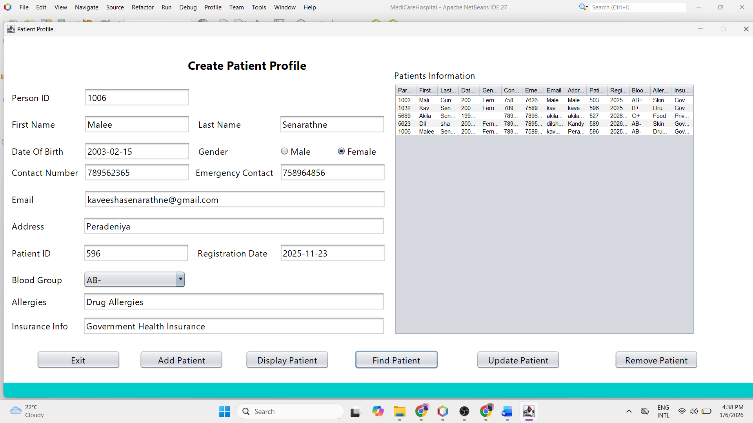Click the **Display Patient** button to view the patient profiles in the table.

1. Find a patient

* 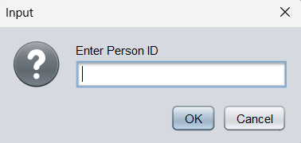Click the **Find Patient** button.
* Enter the Person ID and click OK.
* 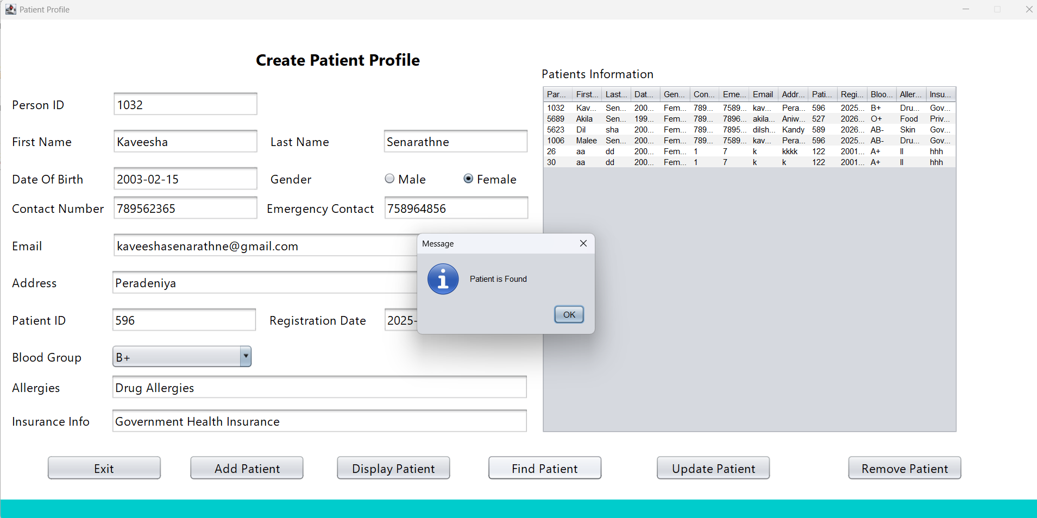The details will appear in the relevant fields.

1. Update Medical Record

* Find the record.
* Update any field.
* 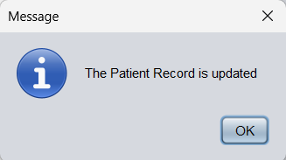Click the **Update Patient** button to save changes.

1. Delete Medical Record.

* Click the **Remove** **Patient** button.
* 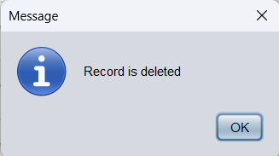Enter the Person ID and click OK.

[*Click here to view the demonstration video.*](https://drive.google.com/file/d/14Esdz5Bf20UNCI_AarhiNkJVDs5SsFBZ/view?usp=sharing)

**Doctor Registration**

The Doctor Registration includes functions such as adding, displaying, finding, updating, and deleting doctor profiles.

The Doctor Registration interface is the same as the Patient Registration interface.

Please refer to that section for more instructions.

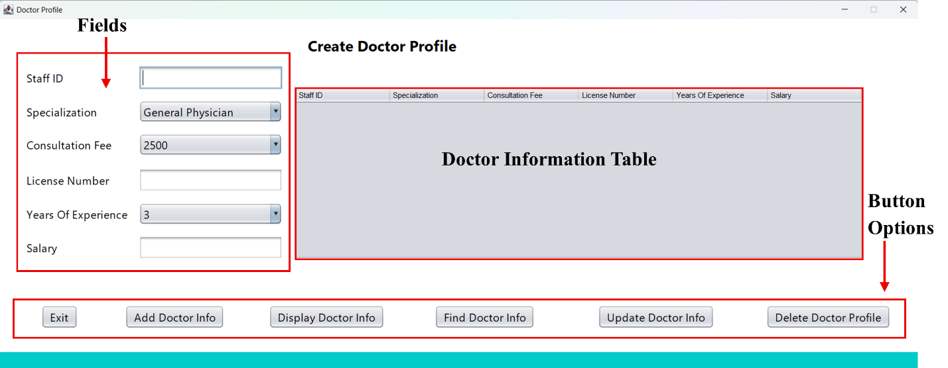

[*Click here to view the demonstration video.*](https://drive.google.com/file/d/1kXNSDgOaCvCW0AjRhvw-uDWeO-qsDQhn/view?usp=sharing)

**Medical Staff Registration**

The Medical Staff Registration includes functions such as adding, displaying, finding, updating, and deleting staff profiles.

The Admin Details interface is the same as the Patient Registration interface.

Please refer to that section for more instructions.

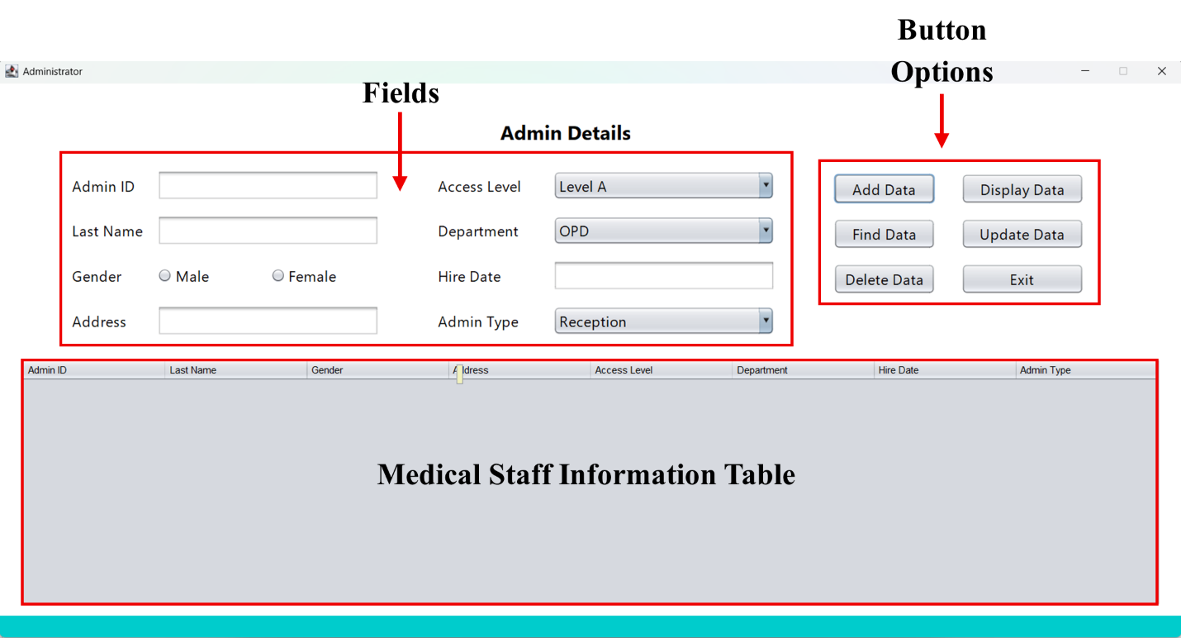

[*Click here to view the demonstration video.*](https://drive.google.com/file/d/1MUB4veZEH-7X3fksqXK8zxrmKhg_aZyo/view?usp=sharing)

**Schedule Appointment**

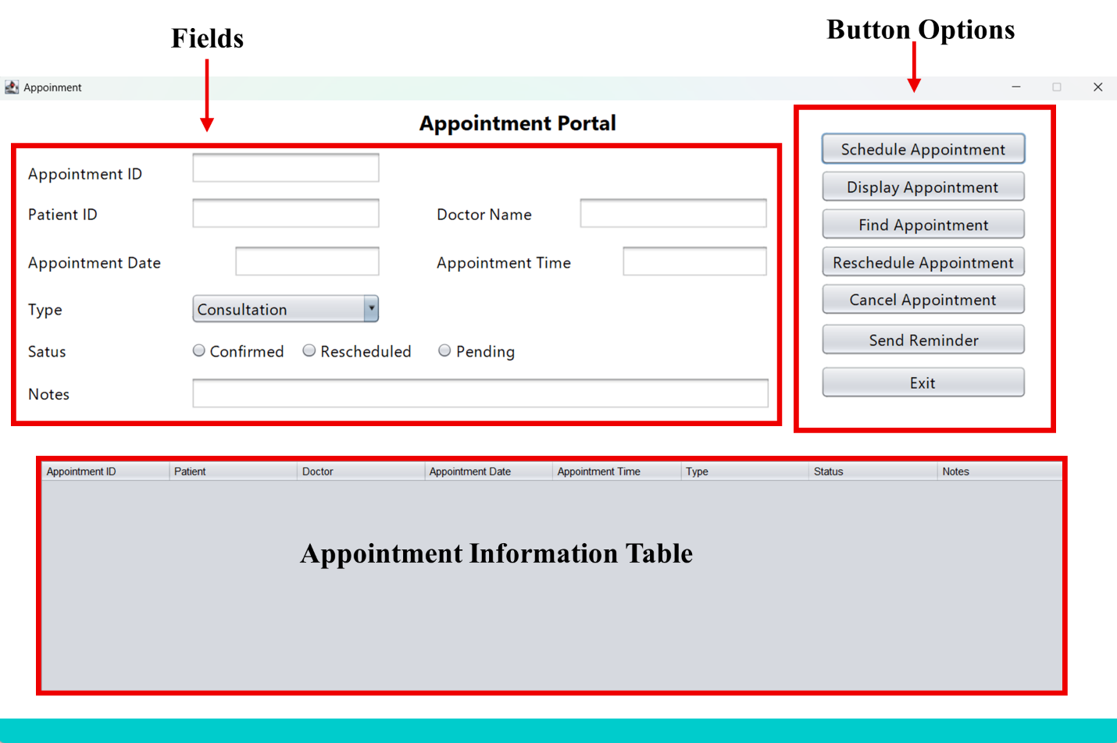The Schedule Appointments feature includes functions such as scheduling appointments, rescheduling appointments, cancelling appointments, sending reminders, and checking and finding appointments.

Follow the steps below:

1. Fill in the appointment fields.

2. Add a new appointment.

* 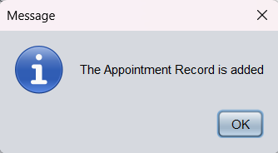Click the **Schedule Appointment** button to save.

1. Display existing appointments

* 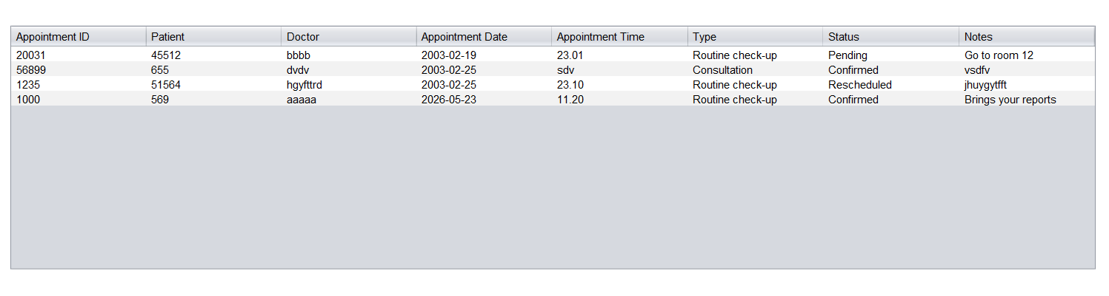Click the **Display Appointments** button to view the appointments in the table.

1. Find an appointment

* 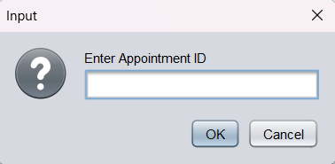Click the **Find Appointment** button.
* Enter the Appointment ID and click OK.
* 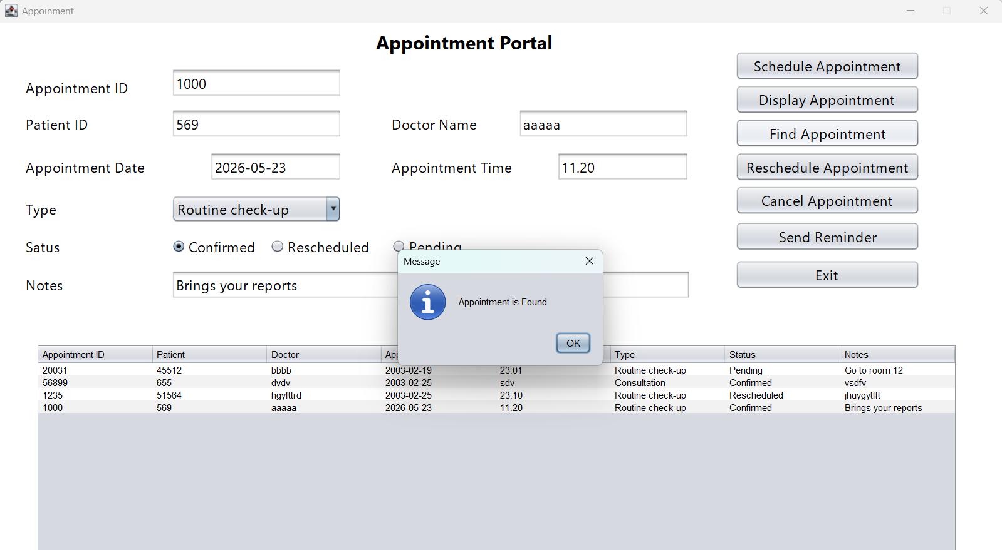The details will appear in the relevant fields.

1. Reschedule appointment

* Find the appointment.
* Update any field.
* 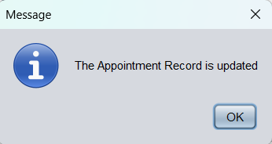Click the **Reschedule Appointment** button to save changes.

1. Cancel appointment.

* Click the **Cancel Appointment** button.
* 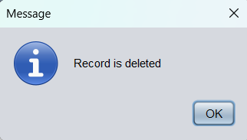Enter the Appointment ID and click OK.

1. Send Reminder

* 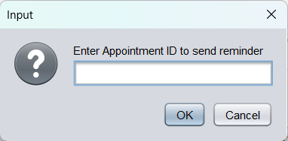Click the **Send Reminder** button.
* 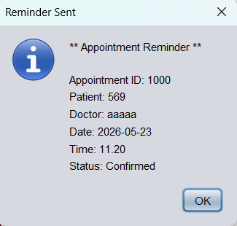Enter the Appointment ID and click OK.

[*Click here to view the demonstration video.*](https://drive.google.com/file/d/17zebuMwZ7Sz32z21hnherxUGa-ODPr8i/view?usp=sharing)

**Payment Process**

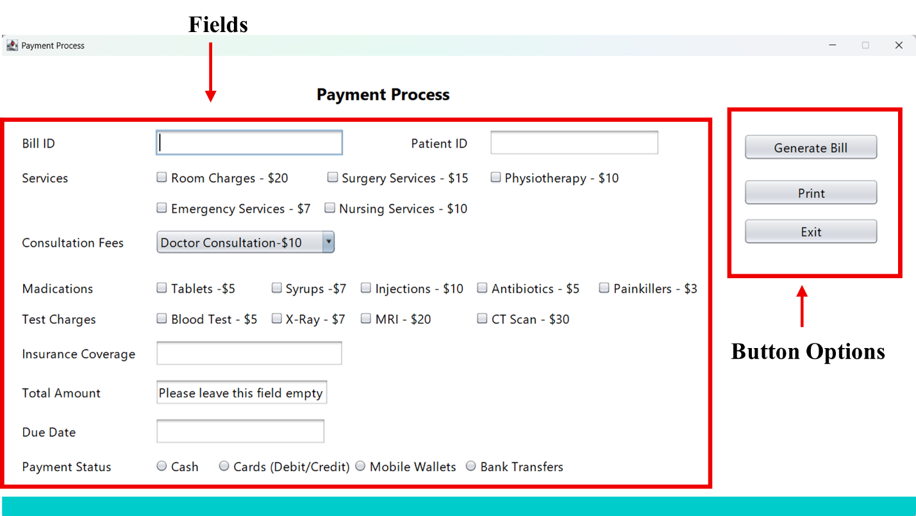

Follow the steps below:

1. Fill in the Payment Process fields.

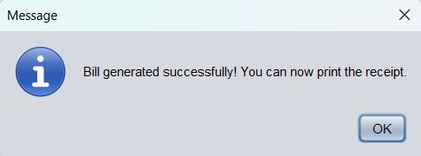2. Click the **Generate Bill** button to calculate the bill.

1. 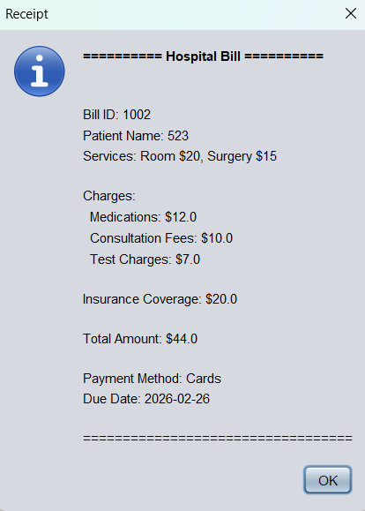Click the **Print** button to get a receipt.

[*Click here to view the demonstration video.*](https://drive.google.com/file/d/17mC12osVlB3UdWbBs7LR2tzz9dn1yJHH/view?usp=sharing)

#### **FAQ**

* Common questions are included in this section.

#### **Contact & Support**

If you have any issues, please contact the following.

* Customer support:

Email: [senarathnemalindi@gmail.com](mailto:senarathnemalindi@gmail.com)

Hotline: +94768670021

* Web & Customer Support:

GitHub: <https://github.com/Kaveeshamalindi>

LinkedIn: <https://www.linkedin.com/in/kaveesha-senarathne-7b6207315/>

Instagram: <https://www.instagram.com/kmalindi0826/>



Thank you